Amy Inoa, Jelissa Reyes, Rahfat Chowdhury

Professor Gil Eckert

CS 104

**Sprint 2 - Accuracy Design Document**

**November 17, 2021**

**Table of Contents**

1. **Executive Summary**

1.1 Project Overview

1.2 Purpose and Scope of this Specification

1. **Product/Service Description**

2.1 Product Context

2.2 User Characteristics

2.3 Assumptions

2.4 Constraints

2.5 Dependencies

1. **Requirements**

3.1 Functional Requirements

3.2 Security

*3.2.1 Protection*

*3.2.2 Authorization and Authentication*

*3.3* Portability

1. **Requirements Confirmation/Stakeholder sign-off**
2. **System Design**

5.1 Algorithm

5.2 System Flow

5.3 Software

5.4 Hardware

5.5 Test Plan

5.6 Task List/Gantt Chart

5.7 Staffing Plan

1. Executive Summary

***1.1 Project Overview***

Your robot must successfully run the figure eight course 5 times. A path will be laid

out on the floor. Your robot must stay within the path provided. Your robot will start and finish in the square provided. Upon finishing, the robot will say ‘I am the winner’ and flash multicolored lights for 5 seconds. Points will be deducted if your robot strays from the path, if it does not go around 5 times, or if it does not finish in the same place it started

***1.2 Purpose and Scope of this Specification***

**In scope**

Testing for the Accuracy course

**Out of Scope**

Testing for the Endurance course

Testing of agility course

1. Product/Service Description

*2.1* ***Product Context***

This is the Accuracy sprint which is the second leg of 3 total sprints including an endurance sprint prior and an agility course to follow.

*2.2* ***User Characteristics***

Create general customer profiles for each type of user who will be using the product. Profiles should include:

* Students will use this product to fulfil course needs.
* The professor will use the product to check functionality.
* This product can be used for mapping out a perimeter of a rectangular room, field, or area.

*2.3* ***Assumptions***

* Robot Srk+ should be fully charged and available for testing.
* Room HH208 should be open and available for testing.
* Group members should be available and ready for testing.
* Course should be placed intact.

*2.4* ***Constraints***

Describe any items that will constrain the design options, including

* Robot cannot go off course
* Room HH208 not being open at certain times
* Robot died mid course
* Meeting with groups was difficult at times due to different schedules

*2.5* ***Dependencies***

List dependencies that affect the requirements.

* Depending on the availability of the room, testing of the course may not be possible
* Other groups may limit the amount of time we have for testing
* Furniture may obstruct the course
* The floor tape may disrupt how the robot runs the course

3. Requirements

3.1 ***Functional Requirements***

| **Req#** | **Requirement** | **Comments** | **Priority** | **Date**  **Rvwd** | ***SME***  ***Reviewed/***  ***Approved*** |
| --- | --- | --- | --- | --- | --- |
| ACCUR_01 | Robot must start on the allotted square | Will finish here as well | ***1*** | 11/17/2021 | Approved - Amy,Rahfat, Jelissa |
| ACCUR_02 | Robot must roll 360 degrees then roll -360 completing one figure eight | Make sure it goes around 5 times | ***1*** | 11/17/2021 | Approved - Amy,Rahfat, Jelissa |
| ACCUR_03 | Robot must repeat ACCUR_02 four more |  | ***1*** | 11/17/2021 | Approved - Amy,Rahfat, Jelissa |
| ACCUR_04 | Robot must say “ i am the winner” and flash multicolored lights for 5 seconds |  | ***1*** | 11/17/2021 | Approved - Amy,Rahfat, Jelissa |
| ACCUR_05 | Blue light has to face the opposite of where it is intended to aim | Blue Light lines up with the end of the starting square | ***2*** | 11/17/2021 | Approved - Amy,Rahfat, Jelissa |
| ACCUR_06 | Aim robot in correct position | Code does not have to change as long as the aim is correct | ***2*** | 11/17/2021 | Approved - Amy,Rahfat, Jelissa |
| ACCUR_07 | Robot has to reach a certain speed to attain a consistent direction |  | ***2*** | 11/17/2021 | Approved - Amy,Rahfat, Jelissa |
| ACCUR_08 | Robot has to stop in the middle of the starting square of the blue tape | Tape might affect the direction of the robot hence the whole course being affected |  | 11/17/2021 | Approved - Amy,Rahfat, Jelissa |

*3.2*  ***Security***

*3.2.1* ***Protection***

*Specify the factors that will protect the system from malicious or accidental access, modification, disclosure, destruction, or misuse. For example:*

* Block code is protected by Sphero Edu User and password log in
* App is protected by personnel login information

*3.2.2* ***Authorization and Authentication***

* Only personnel working on the Accuracy course have access to the code.
* Program could only run if logged into a personal device and Sphero edu app.

*3.3* ***Portability***

*If portability is a requirement, specify attributes of the system that relate to the ease of porting the system to other host machines and/or operating systems. For example,*

* Robot can only run on course in room HH208
* Robot cannot function if not connected to a nearby device

4. Requirements Confirmation/Stakeholder sign-off

11/16/21 Jelissa (organizer), Amy (organizer Setup SDD, gantt chart, requirements table, and staffing plan

11/17/2021 Jelissa (organizer), Amy (organizer), Rahfat (organizer) Set up Algorithm, Worked on block code, ran the robot, took video, gantt chart, SDD document

11/18/2021 Amy (organizer), Rahfat (organizer) Worked on getting a better block code

| **Meeting Date** | **Attendees ( name and role)** | **Comments** |
| --- | --- | --- |
| 11/16/21 | Jelissa (organizer), Amy (organizer) | Setup SDD, gantt chart, requirements table, and staffing plan |
| 11/17/2021 | Jelissa (organizer), Amy (organizer), Rahfat (organizer) | Set up Algorithm, Worked on block code, ran the robot, took video, gantt chart, SDD document |
| 11/18/2021 | Amy (organizer), Rahfat (organizer) | Worked on getting a more sufficient block code |

5. System Design

*5.1* ***Algorithm ()***

First we will program the robot to loop 5 times.

While it’s in the loop, we will put the robot’s speed to 60.

Then we will make the robot spin at 360 degrees for 8.4 seconds.

Then we will make it stop.

The robot’s speed will again be 60.

Then it will spin at -360 degrees for 7.9 seconds.

After that the loop will come to an end and the robot will stop.

The robot will say, “I am the winner,” and wait.

The robot will fade from red to yellow over 1.2 seconds.

Then it will fade from blue to pink over 1.2 seconds.

Then we will exit the program.

*5.2* ***System Flow***

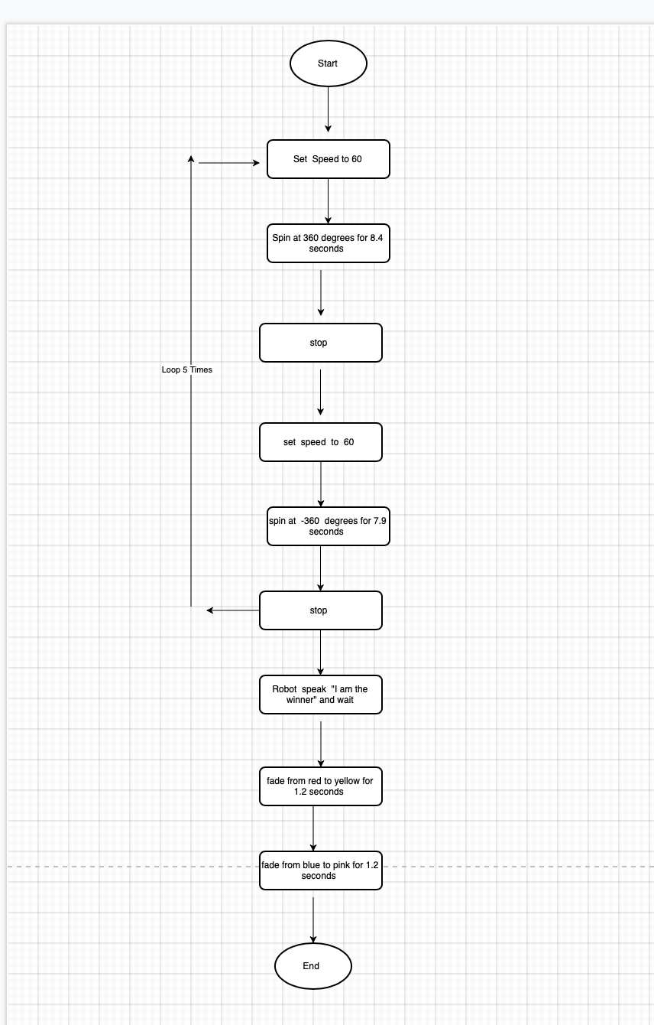

*5.3* ***Software***

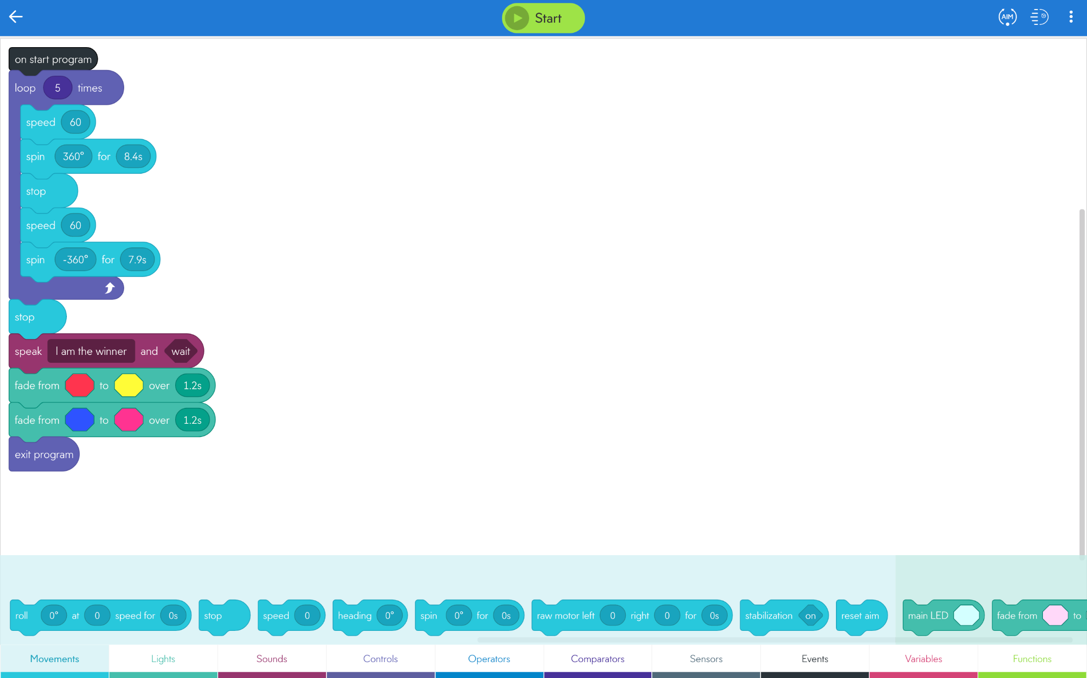

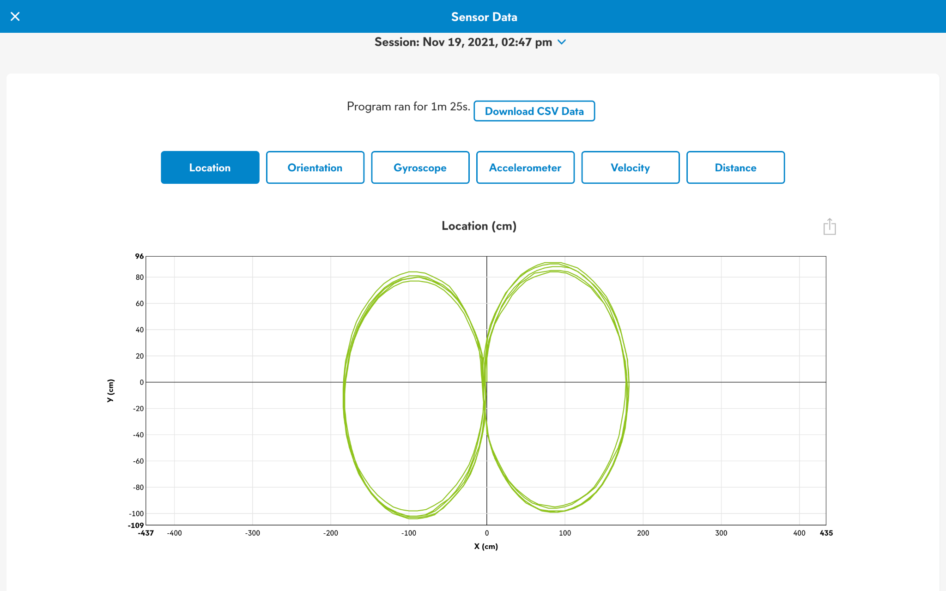

*5.4* ***Hardware***

*Sphero Sprk+ Robot*

*Laptop*

*5.5* ***Test Plan***

| **Reason for Test Case** | ***Test Date*** | ***Expected out come*** | ***Observed***  ***Output*** | ***Staff Name*** | ***Pass/Fail*** |
| --- | --- | --- | --- | --- | --- |
| To check if the robot will complete one of the circles and stop on the middle line | 11/17/2021 | Robot should travel radius of the first circle and stop on the middle | Robot cut through the middle of the circle and did not complete the full circle | Amy | Fail |
| Confirm that the code for the first circle has the correct amount of time and speed to compete the full first circle | 11/17/2021 | Robot should travel the outside of the first circle and stop on the middle line | 8 seconds at 63 speed | jelissa | pass |
| Confirm that the first circle stops in the middle and completes the opposite circle and stops in the middle and completes the full figure 8 | 11/17/2021 | Robot should end on the middle lane after one full figure 8 | Robot completed the first circle but rolled to wide on the second circle and collided with a chair | Rahfat | fail |
| Check the initial speed is corrected and with the relevant time in seconds | 11/17/2021 | Robot should complete 1 full figure 8 | Robot completed 1 figure 8.  8 seconds and 63 speed | Amy | pass |
| Check if the robot flashes lights and speaks after 1 figure 8 | 11/17/2021 | Robot should say i am the winner and flash the light for 5 seconds | Robot spoked and flashed lights upon stopping | Jelissa | Pass |
| Check if the robot completes 5 full figure eights and flashes lights and speaks | 11/17/2021 | Robot should complete 5 full figure 8’s, speak and flashlights upon stopping | Robot completed 2 figure 8’s, then was pushed off course by uneven tape | Rahfat | Fail |
| Check if aiming the robot slightly outward will help avoid uneven tape | 11/17/2021 | Robot should complete the course | Aim did help avoid collision, but the robot will still either roll to far out or to far in | Amy | fail |
| Minor adjustments to aim and check if robot completes course | 11/17/2021 | Robot should complete course | Robot  completed the course, spoke the correct statement, and flashed lights for 5 seconds | Jelissa | pass |
| Another trial to see if robot will travel the course exactly again | 11/17/2021 | Robot should complete course | Robot completed course while rolling a little more aligned with blue tap | Rahfat | pass |

*5.6* ***Task List/Gantt Chart***

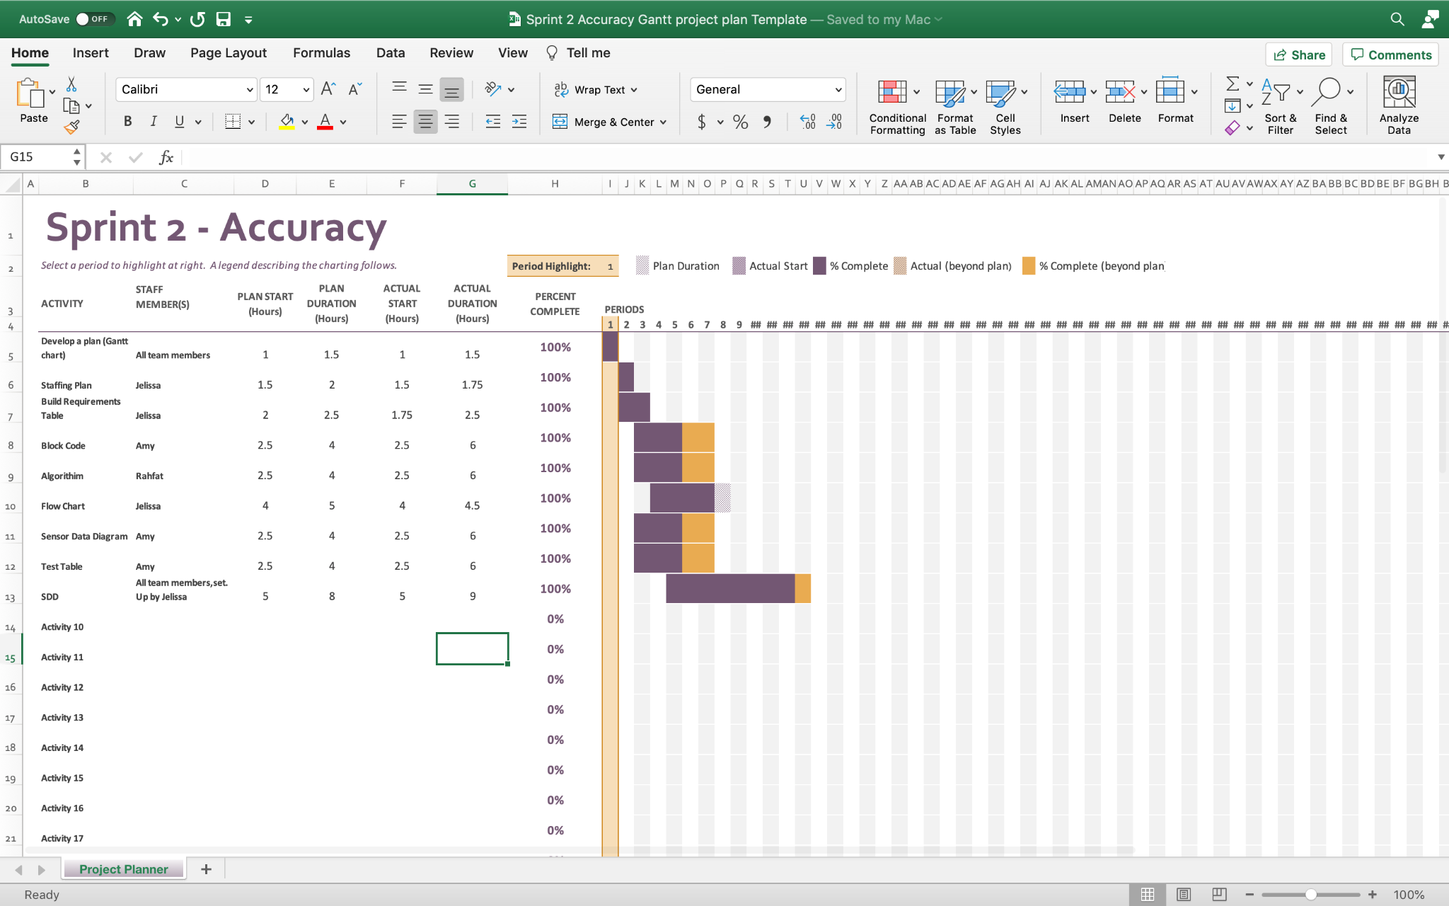

5.7 ***Staffing Plan***

| Name | Role | Responsibility | Reports To |
| --- | --- | --- | --- |
| Jelissa | Organizer | Help set up SDD, gantt chart, staffing plan, requirements table, flowchart, help with coding | Amy and Rahfat who will give information, and to assign requirements and for code for flowchart |
| Rahfat | Organizer, videographer | Coding, algorithm, Sensor Data Diagram, video | Jelissa and Amy who will be making the SDD and helping |
| Amy | Organizer, programmer | Coding, help set up SDD, test table, gathered data | Rahfat and Jelissa who will be coding and helping with the SDD, and gathering info |